# Title: Mastermind Electronic Edition

**Interim report**

Name: Michal Bochenek

Matric No: 40270585

Introduction

A Mastermind is a game in which one player sets a secret code and the other player is trying to guess the sequence by placing the coloured pins in the holes, with each attempt (usually 12 attempts per game) the player is given feedback on how many colours were guessed right and how many pins were placed in the right position.   
The game usually uses 4 pin holes and 6 colours. The proposed solution will differ from the original in such a way that a player who creates the secret code is replaced by the random pin sequence at the game start, the game starts once the player connects via Bluetooth to the Arduino device.   
To make things run easier for the prototype and due to the pin number the player will have less colours to choose from yet also less attempts to guess the code.

Aim of this project is to enhance student knowledge and practical application of the already possessed skills gained during the subject classes.  
The project will intend to deliver:   
- working game – a smartphone application  
- an Arduino device connected over Bluetooth with the game app  
- any required documentation containing project technical aspects etc.

Current status

The research during analysis wasn’t broad since all of the requirements for the successful delivery of the project was based on using existing skills gained from the previous classes, such as smartphone app GUI development, Bluetooth communication between two paired devices, how does shift register work, RGB LED lights colour pins check-up, and also the necessary electronic parts were analysed and they are as such:  
  
Items required to deliver the project:

- 3 x RGB LED lights

- 3 x Yellow LED lights

- 3 x Red LED lights

- Connection cables

- A large breadboard

- Arduino Uno or similar, powered via USB cable or batteries

- 15 x 330 Ohm Resistors

- 3 x 1k Ohm Resistors to create voltage divider (2:1 ratio)

- 74HC595 - 8-bit serial-in, serial or parallel-out Shift Register

- Android Smartphone with built in Bluetooth

- Bluetooth transmitter/receiver for Arduino (receiver at least)

Technological requirements:

- Arduino version 1.8.1 programming development environment

- Processing version 3.3 to create the Android application, it was discovered that processing can handle Arduino connection with proper libraries so that it can handle GUI side, game logics and communication with the Arduino

- Processing GUI builder tool – G4Ptool version 4.2

- Processing Bluetooth communication – Ketai library

Outcome of analysis process:  
- Arduino has only 14 pins available and the device would be using 17 outputs so that a solution to this problem is shift register, which will require itself 3 outputs but provides 8 additional pins, 6 of which will be used for red and yellow led lights. This reduced overall design to exactly 14 output pins.

- Since it’s a good practice to draw something first, then create it - the prototype design was first created with the use of Autodesk Circuits and it was shown below:  
(Bluetooth was missing from the list of components and it was replaced with LM393 chip)

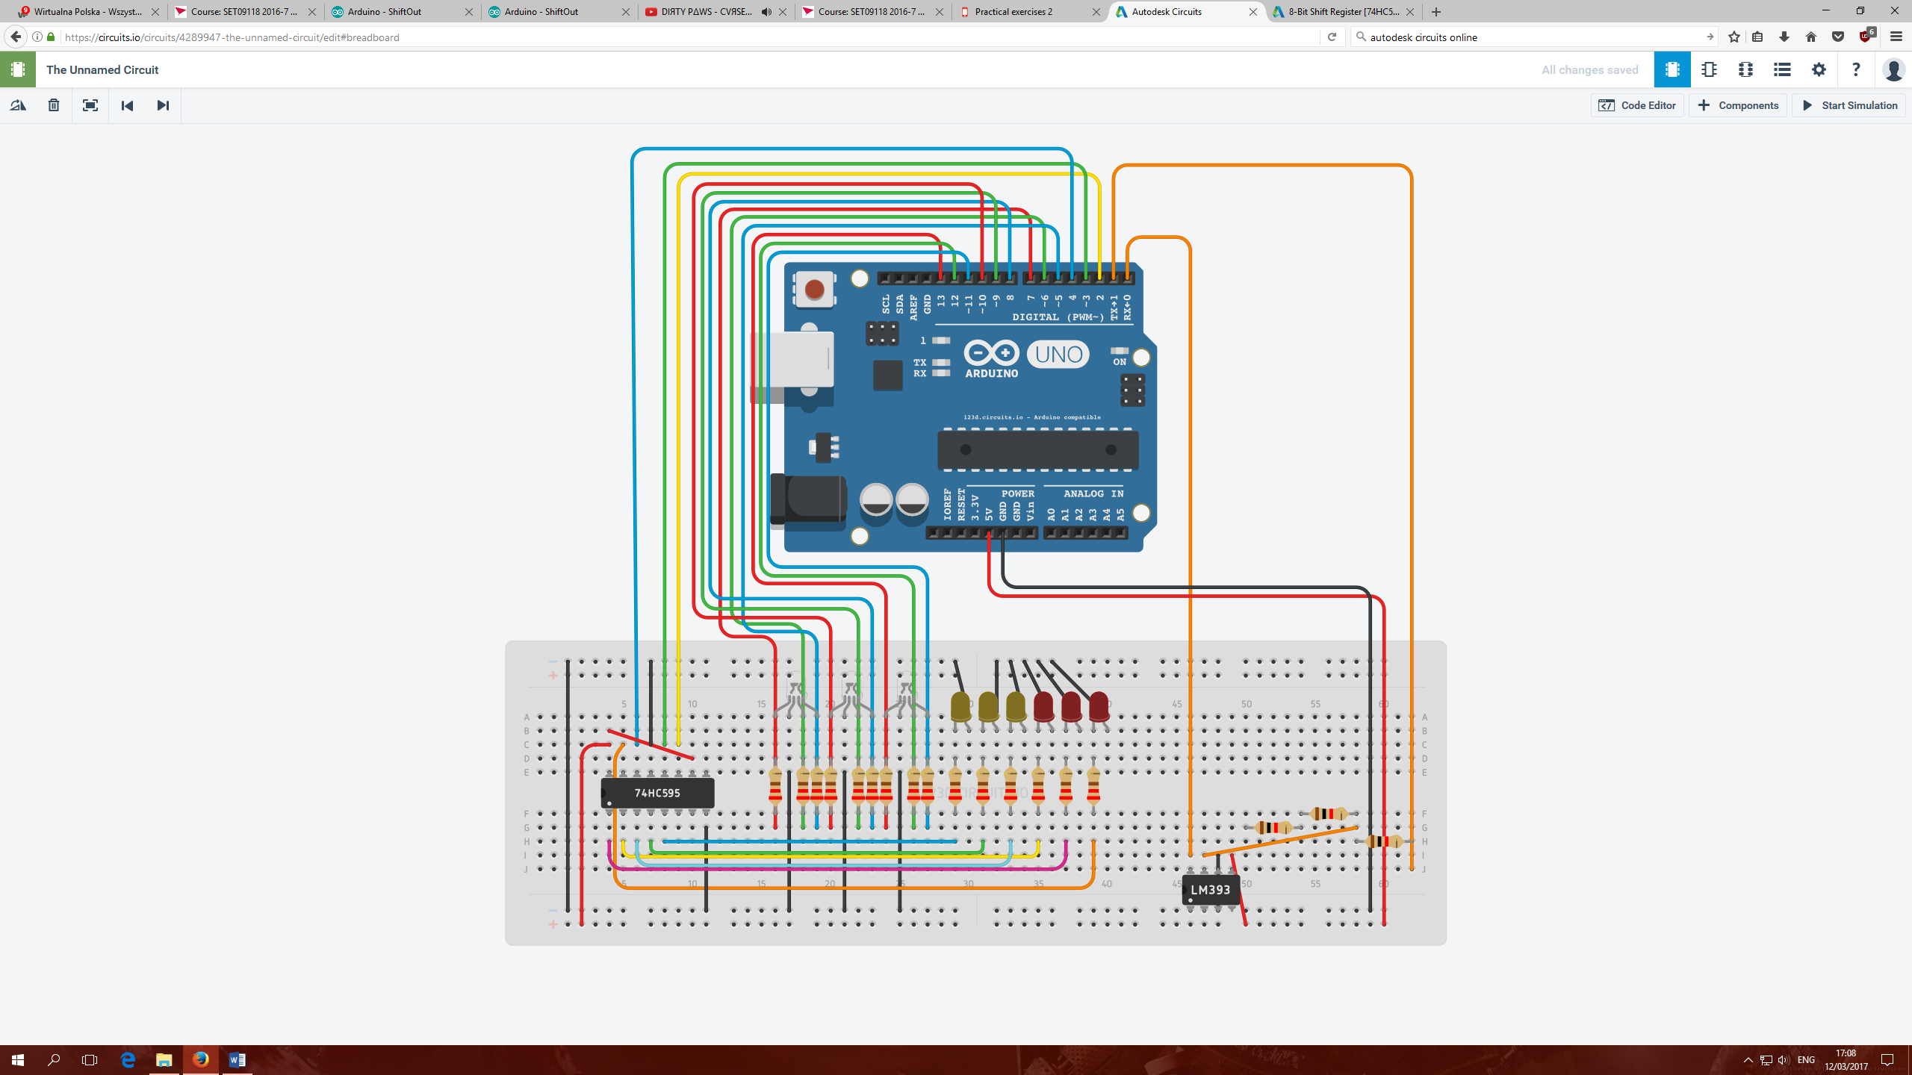

This prototype was then built and tested with basic application lighting all LEDs:  
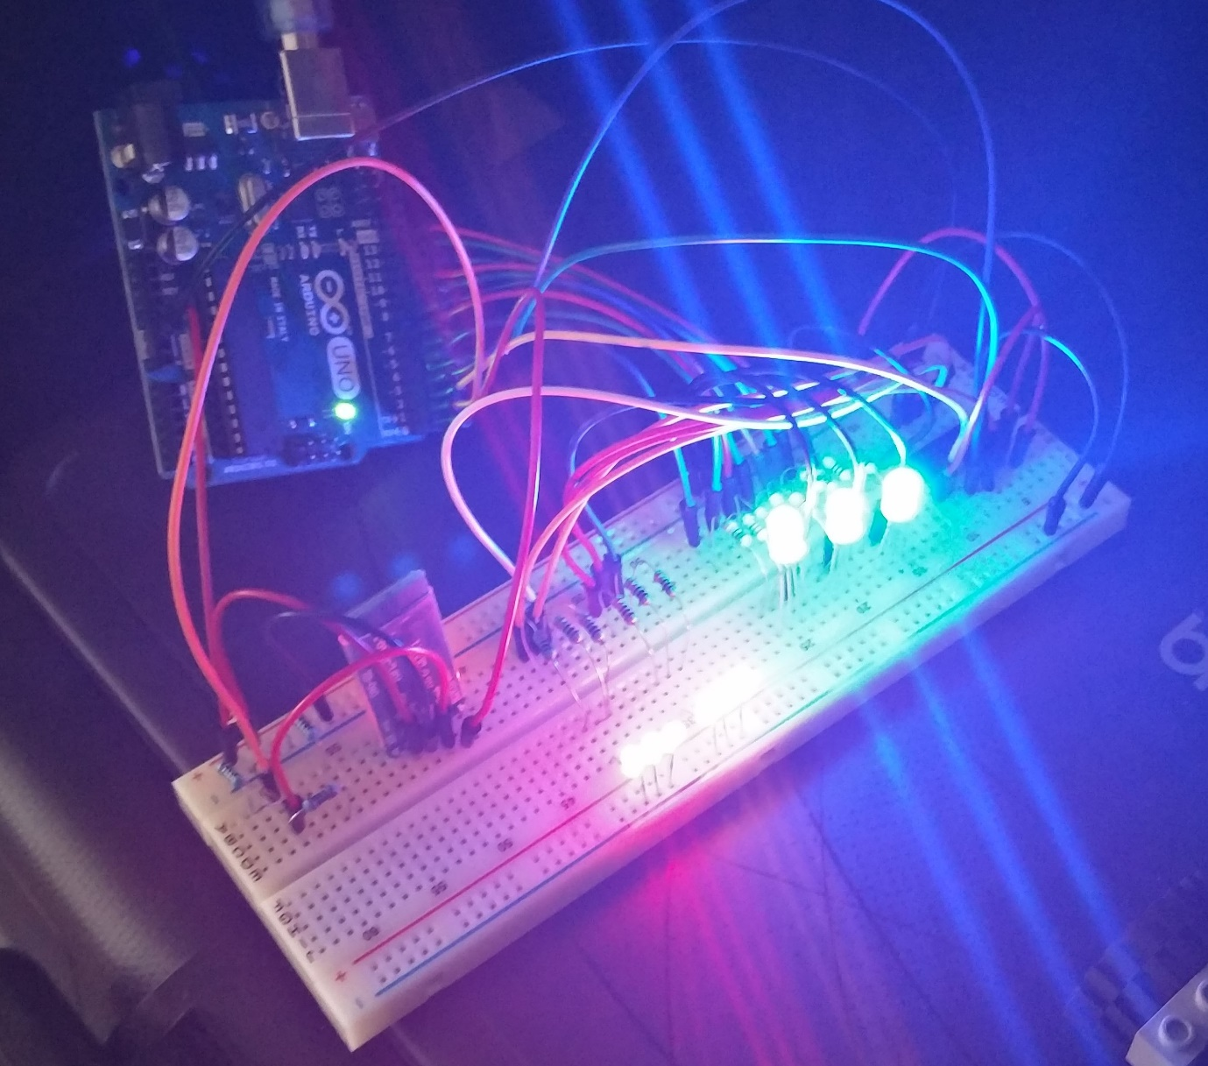

Additionally Bluetooth was connected but not configured in order to check if Arduino will handle all the items turned on at the same time without any issues.  
  
Given the positive results, the next stage was to create an application draft design which will provide the user ability to interact with the system such as:  
- choose sequence of 3 colours (blue, red, green, white, purple),  
- send processed user input to Arduino to see the results,  
- check game status,   
- manage game start and end

A simple UML draft was created to have an outlook on system proposed behaviour:

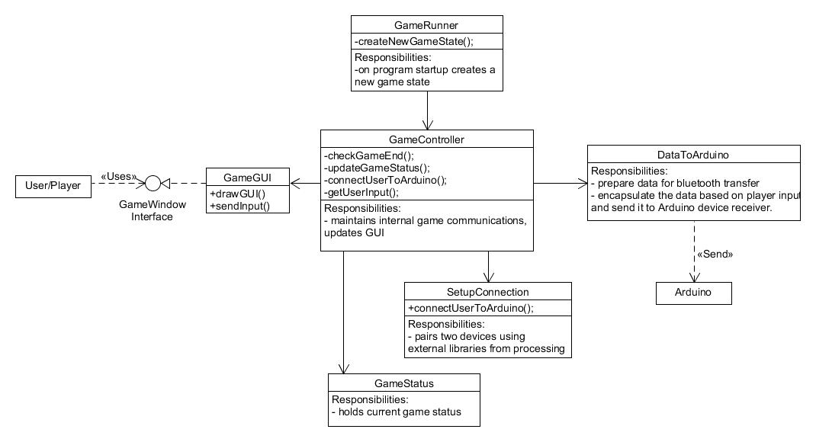

And User GUI draft as proposed is:  
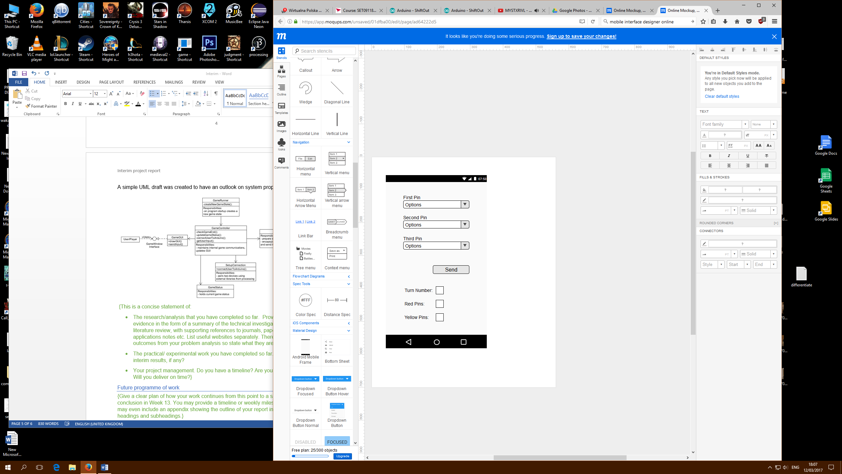

The project has a schedule and according to it the student is on track, the report was written before progressing to current week’s next stage - to develop the Android application. The online resources accessed and found are mentioned in bibliography.

Future programme of work

|  |  |  |
| --- | --- | --- |
| Date | Deliverable | Comment |
| 17/02/2017 | Project initial documentation | * Completed |
| 24/02/2017 | Project device scheme, and application GUI draft | * Completed |
| 03/03/2017 | Project initial device and GUI working prototypes | * Completed |
| 10/03/2017 | Catch up work | * Interim report and start of application development |
| 17/03/2017 | Development of the application game logics and first release for testing |  |
| 24/03/2017 | Any other catch up work if needed |  |

Issues and concerns

Currently it is not known yet if Processing GUI building external tool will work as expected, although initial try-out shown positive results.  
A better understanding of how data is sent over Bluetooth must be made so that the application can send a nice single package to Arduino to be read and used.

References

[1]"Arduino Playground - Processing", *Playground.arduino.cc*, 2017. [Online]. Available: http://playground.arduino.cc/Interfacing/Processing. [Accessed: 15- Feb- 2017].

[2]"Arduino - ShiftOut", *Arduino.cc*, 2017. [Online]. Available: https://www.arduino.cc/en/Tutorial/ShiftOut. [Accessed: 12- Mar- 2017].

[3]"Bring ideas to life with free online Arduino simulator and PCB apps | Autodesk Circuits", *Circuits.io*, 2017. [Online]. Available: https://circuits.io/. [Accessed: 12- Mar- 2017].

[4]"Connecting Arduino to Processing - learn.sparkfun.com", *Learn.sparkfun.com*, 2017. [Online]. Available: https://learn.sparkfun.com/tutorials/connecting-arduino-to-processing. [Accessed: 15- Feb- 2017].

[5]"Mastermind (board game)", *En.wikipedia.org*, 2017. [Online]. Available: https://en.wikipedia.org/wiki/Mastermind_(board_game). [Accessed: 15- Feb- 2017].

[6]P. Goldsborough, "Arduino and Multiplexing", *Thecodeinn.blogspot.co.uk*, 2017. [Online]. Available: http://thecodeinn.blogspot.co.uk/2013/10/arduino-and-multiplexing.html. [Accessed: 15- Feb- 2017].  
[7]"Online Mockup, Wireframe & UI Prototyping Tool · Moqups", *Moqups.com*, 2017. [Online]. Available: https://moqups.com/. [Accessed: 12- Mar- 2017].

[8]"Quarks Place", *Lagers.org.uk*, 2017. [Online]. Available: http://lagers.org.uk/g4ptool/index.html. [Accessed: 12- Mar- 2017].